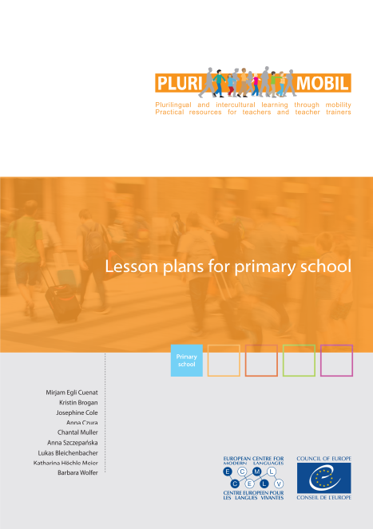

**PluriMobil**

**Lesson plans for primary school**

Table of contents

Introduction to PluriMobil lesson plans 2

Lesson plan 1 My self-portrait 4

Lesson plan 2 My silhouette 9

Lesson plan 3 Exploring the surroundings 13

Lesson plan 4 The same and different 17

Lesson plan 5 Let’s offer them something! 20

Lesson plan 6 Typical 22

Lesson plan 7 My treasures – My special things to bring back 23

Lesson plan 8 Delicious! My appetite for culture 25

Lesson plan 9 The European Language Portfolio: How do I learn languages? 28

Lesson plan 10 The words I need … 31

Lesson plan 11 I understand more than I think 33

Lesson plan 12 I will show you my town 37

# Introduction to PluriMobil lesson plans

These lesson plans are the core element of PluriMobil (Mobility for sustainable plurilingual and intercultural learning). Before using the Lesson Plans, please consult the PluriMobil quick start guide that demonstrates in a few easy steps how to start using PluriMobil lesson plans. You will find more detailed information and numerous practical tips as to how the lesson plans can be used to support mobility experiences in the PluriMobil Handbook. Both documents are available on the PluriMobil website <http://plurimobil.ecml.at>.

The term “lesson plan” can mean *one* period of teaching of e.g. 45 or 60 minutes that can take place before, during and after the mobility activity, but it can also mean *several periods* of teaching. It is not necessary to use all the lesson plans. –Teachers are free to select the lesson plans that best address their students’ needs. The detailed organisation of the activity and the timing are up to the teacher.

# 1. Structure of the lesson plans

In the lesson plans, you will find the following rubrics:

* A short summary with information about the content of the lesson plan.
* Experiences: the different kinds of experiences the pupils can gain with the suggested activities
* Targeted competences: a list of linguistic, intercultural, personal etc. competences pupils can achieve during the activities
* Suggestions for procedure: description of possible content and development of the activity, separated into the different phases of mobility (before – during – after)
* Suggestions for the final product for the portfolio
* Tools and resources: this section refers to pedagogical instruments developed by the Council of Europe such as the *European Language Portfolio* (ELP) or the *Autobiography of Intercultural Encounters* (AIE) as well as to other sources such as websites, books, pictures etc.
* Examples: this section refers to ready-made worksheets or possible examples supporting the suggested activities

# 2. Use of the lesson plans

We would like to point to the following issues:

* **Description of procedure**: all the activities described in the lesson plans are *suggestions* that you can adapt to your own context and needs.
* **Flexible order**: all lesson plans can be used in a *variable order*; you do not have to use one lesson plan after the other. The choice depends on your needs and context (type of mobility activity, age of pupils, available resources, etc.)
* **Phases of mobility**: the lesson plans contain descriptions of activities for one, two or three phases of the mobility activity. Depending on your context, it is possible to use a lesson plan for a phase other than the one described. We recommend that you do all three phases of mobility; but this is not compulsory for the successful use of a lesson plan.
* **Language of the activity**: activities can be carried out in the school language or in the target language, depending on the pupils’ level of competence. For the development of competences in the target language on levels A1/A2, we recommend Lesson Plans 1, 2, 5, 10 and 11.
* **Examples:** the example provided in the lesson plan is just *one* example. It is possible that the results from your pupils will look different.
* The examples from the *European Language Portfolio* are taken from e.g. the Swiss version. Of course, you can use the ELP from your own or another country if you need the examples in another language.
* **Reciprocity:** In the case of a mobility activity where the sending and hosting institutions are involved, we recommend that both sides do similar activities so that pupils can exchange experiences and complete the suggested activities in the during-phase together.

# 3. List of quoted tools in the lesson plans (with hyperlinks)

[Autobiography of Intercultural Encounters](http://www.coe.int/t/dg4/autobiography/autobiographytool_EN.asp) (AIE). Council of Europe, 2009.

[Common European Framework of Reference for Languages: Learning, Teaching, Assessment](http://www.coe.int/t/dg4/linguistic/cadre1_en.asp)(CEFR). Council of Europe, 2011.

[Developing and Assessing Intercultural Communicative Competence](http://archive.ecml.at/mtp2/ICCinTE/html/ICC_E_Results.htm) (ICCinTE). Council of Europe, 2007.

[European Language Portfolio](http://elp-implementation.ecml.at/) (ELP). Council of Europe.

[Framework of Reference for Pluralistic Approaches to Languages and Cultures](http://carap.ecml.at/)(FREPA). Council of Europe, 2007.

**4. List of icons used.**

|  |  |  |  |  |  |
| --- | --- | --- | --- | --- | --- |
| plurimobil-icon-individual-work-blue | individual work | plurimobil-icon-pair-group-work-blue | pair or group work | plurimobil-icon-discussion-blue | discussion |
| plurimobil-icon-speaking-blue | speaking | plurimobil-icon-writing-blue | writing | plurimobil-icon-listening-blue | listening |
| plurimobil-icon-reading-blue | reading | plurimobil-icon-observing-blue | observing | plurimobil-icon-reflexion-blue | reflection |
| plurimobil-icon-question-blue | question | plurimobil-icon-presentation-blue | presentation | plurimobil-icon-virtual-exchange-blue | using ICT |

# Lesson plan 1 My self-portrait

**In this lesson plan the pupils prepare booklets about themselves to show their mobility partners.**

We suggest that the activity before the mobility project is done in both the host and the guest school, so that it can be used later on for when they meet. This makes it easier for the pupils to exchange the same kind of information.

# EXPERIENCES

Pupils

* think about their own daily lives
* describe themselves
* compare their daily lives with other people in the class and with other people from different places

# TARGETED COMPETENCES

Pupils

* can better understand their own cultural identity (ICCinTE, p. 13)
* can perceive differences and similarities in different aspects of social life (FREPA, skills, S-3.10.2)
* can compare features of culture (perceive the cultural proximity/distance) (FREPA, skills, S-3.10)
* can deal with cultural diversity in the classroom (ICCinTE, p. 12)
* can write very short pieces of text; isolated words and very short, basic sentences (CEFR, A1, p. 240)

# PROCEDURE

BEFORE

|  |  |
| --- | --- |
| plurimobil-icon-listening-blueplurimobil-icon-observing-blue | The teacher prepares a small booklet about him/herself as an example, and presents it to the class. |
| plurimobil-icon-writing-blueplurimobil-icon-individual-work-blue | Later children will prepare a booklet about themselves. It will include basic information like   * name * photo/drawing (+ caption) of themselves * photo/drawing (+ caption) of family * photo/drawing (+ caption) of pets/house * photo/drawing (+ caption) of favourite game/sport * …   Taking the multicultural background of many children into account, we would like to stress that in the “I am” and “I speak” sections of the booklet, children can tick as many boxes as they find necessary.  For younger children parents may help.  Children also bring a small object that is very important to them. |

|  |  |
| --- | --- |
| plurimobil-icon-listening-blueplurimobil-icon-discussion-blue | Children present their booklet to their classmates. They also show their special object and explain why they have chosen it.  The other children are invited to ask questions (maximum 5).  We suggest spreading the presentations over a week (5 children a day). |
| plurimobil-icon-observing-blueplurimobil-icon-reading-blue | The booklets are displayed in the classroom so that all children can view and talk about them at their leisure.  They prepare a series of questions to ask their partners (depending on the information described in the booklet).  E.g. What’s your surname? What’s your first name? Where do you live? Have you got pets? What are their names? What’s your favourite colour? Etc. |

DURING

|  |  |
| --- | --- |
| plurimobil-icon-reading-blueplurimobil-icon-pair-group-work-blue | The children can use their booklets to introduce themselves. It will make them feel more secure and at ease, as the drawings/pictures will speak for themselves.  Speed-dating – Children sit two per table and introduce themselves to their partner. After two/three minutes they change roles. They use the questions prepared in advance. |

AFTER

|  |  |
| --- | --- |
| plurimobil-icon-writing-blueplurimobil-icon-individual-work-blue | The booklets can be completed with other tasks   * I liked … * I enjoyed … * I was surprised by …   Of course, all children’s ideas are welcome. |

# FINAL PRODUCT FOR THE PORTFOLIO

A booklet – Self-portrait

# TOOLS AND RESOURCES

A booklet providing a self-portrait of the pupils (see the examples section)

Example   
See suggestion of a booklet to be filled in.

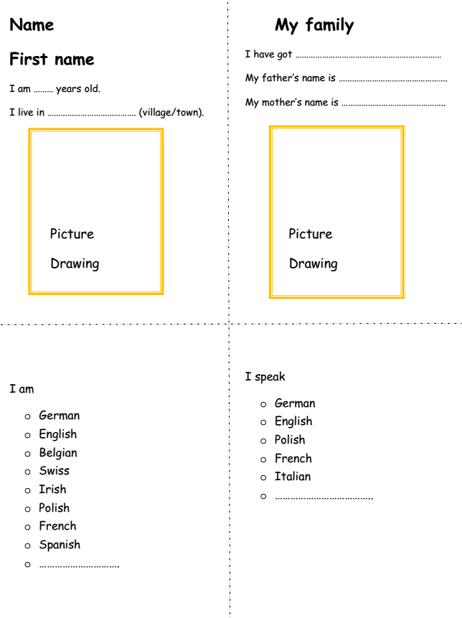

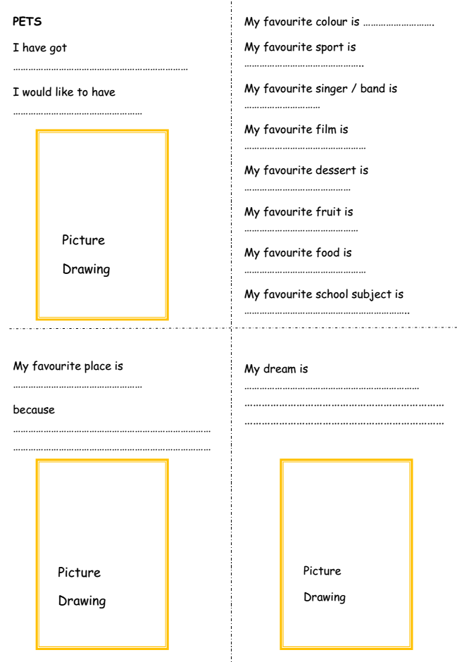

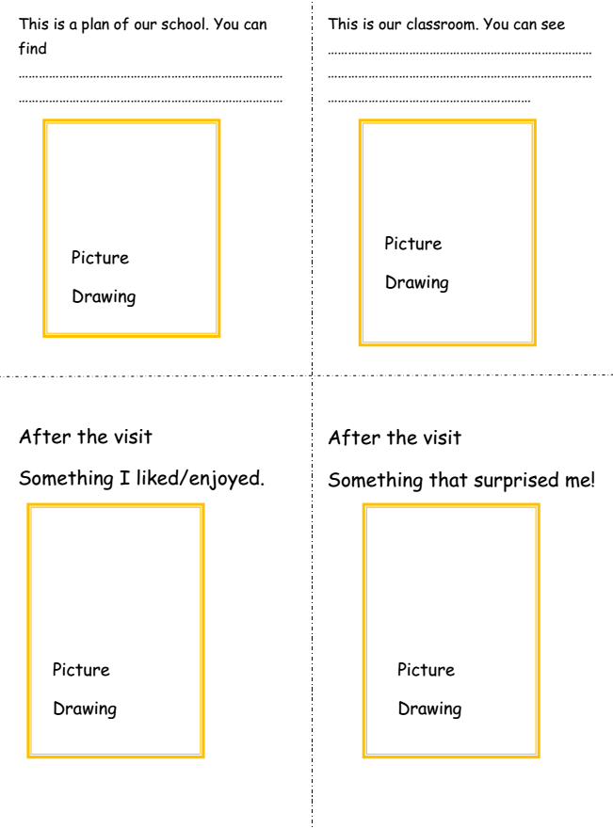Lesson plan 2  
My silhouette

**In this lesson the pupils draw silhouettes of themselves to observe similarities and differences between different people.**

We suggest that the activity before the mobility project is done in both the host and the guest school, so that it can be used later on for when the pupils meet each other.

# EXPERIENCES

Pupils

* describe themselves
* notice that all children have things in common
* notice that all children are different

# TARGETED COMPETENCES

Pupils

* learn attitudes of openness, curiosity and non-judgmental thinking (ICCinTE, p. 14)

# PROCEDURE

BEFORE

|  |  |
| --- | --- |
| plurimobil-icon-observing-blueplurimobil-icon-listening-blue | The teacher models the drawing of the silhouette and explains the purpose of the lesson. Pupils must describe themselves, writing their feelings inside the shape of the silhouette, and the activities they do/objects they like outside. |
| plurimobil-icon-writing-blueplurimobil-icon-discussion-blue | We suggest drawing a child size silhouette first, with all the class contributing ideas for the inside and outside.  They can also draw arrows:   * from the heart: what they like * from the foot/hand: what they do * outside: objects |
| plurimobil-icon-writing-blueplurimobil-icon-individual-work-blue | Then the children can draw their own small size silhouette on individual sheets. |
| plurimobil-icon-speaking-blueplurimobil-icon-pair-group-work-blue | In pairs, children talk about their silhouette and how they filled it in. |
| plurimobil-icon-pair-group-work-blue | Two pairs of children meet and share one interesting thing about what they have learnt about their partner. |

DURING

|  |  |
| --- | --- |
| plurimobil-icon-speaking-blueplurimobil-icon-discussion-blue | The children can use their silhouette or the class silhouette when meeting the other partner (?) class. (See lesson plan 1) |

AFTER

|  |  |
| --- | --- |
| plurimobil-icon-reflexion-blueplurimobil-icon-writing-blue | The children can add something to their silhouette, something they have done, seen, experienced, felt during the mobility activity. |

# FINAL PRODUCT FOR THE PORTFOLIO

Completed silhouette (class + personal)

# TOOLS AND RESOURCES

A blank silhouette to be filled in (see the examples section)

Example 1

**Example of a filled in silhouette**

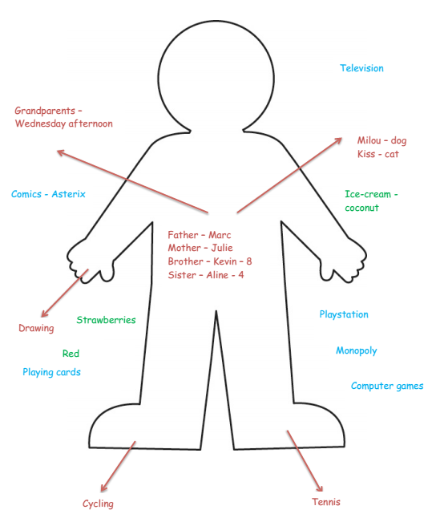

Example 2

**Example of a silhouette to be filled in**



# Lesson plan 3 Exploring the surroundings

**In this lesson plan the pupils try to discover interesting aspects of their own surroundings.**

# EXPERIENCES

Pupils

* look and learn about places in their surroundings
* talk about places they know
* notice that there are different ways of living and different places which they live in or know about
* get involved in their mobility activity

# TARGETED COMPETENCES

Pupils

* can better understand their own cultural identity (ICCinTE, p. 13)
* can perceive differences and similarities in different aspects of social life (FREPA, skills, S-3.10.2)
* can compare features of culture (perceive the cultural proximity/distance) (FREPA, skills, S-3.10)
* can deal with cultural diversity in and outside of the classroom (ICCinTE, p. 12)

# PROCEDURE

BEFORE

|  |  |
| --- | --- |
| plurimobil-icon-discussion-blueplurimobil-icon-observing-blue | The teacher shows several photographs to the pupils, of objects they would usually easily recognise but which have been photographed this time from an unusual angle.  Pupils discuss what they see and try to guess what the objects are. Pupils analyse the objects in the photographs (colour, shape, material, etc.) in order to guess what they are.  In groups, pupils decide what they would like to take pictures of (limited number), in order to show these objects later to others (The pupils will put these photos in a scrapbook to present to the other pupils when visiting/ to send in advance/ to create an exhibition while hosting the other pupils). |
| plurimobil-icon-individual-work-blueplurimobil-icon-observing-blue | Pupils take photos of their surroundings   * classroom * school * playground * street * village * … |
| plurimobil-icon-pair-group-work-blueplurimobil-icon-writing-blue | Starting with the photographs the pupils have taken of their own surroundings, the pupils talk about what they might see in the place they will visit (including similarities, differences)  The pupils imagine what these places will be like, and draw them e.g.   * the school * playground * houses * shops * monuments * …   When planning the day of the visit, the pupils talk about what they might expect to see or do. Following this, they decide if they need to bring along anything special for the activities they have listed. |

DURING

|  |  |
| --- | --- |
| plurimobil-icon-presentation-blue | The pupils can use the scrapbook idea or any other presentation method to introduce their surroundings. It will make them feel more secure and at ease, as the drawings/pictures will speak for themselves. |
| plurimobil-icon-observing-blue | In groups, the pupils choose either a topic, a place or an object to explore a bit more. They take some photographs of.  E.g. doors, window frames, …  things that are round/square/…  things that are red/green/…  things that are made of wood/plastic/… |
| plurimobil-icon-speaking-blueplurimobil-icon-pair-group-work-blue | Alternative  In groups, the pupils choose one place/house that they like. They discuss what features they want to report on. Then they decide how they would like to represent what they have chosen when they are back at home   * 3D mode * sketch or drawing * puzzle * painting/poster * collage * crosswords * PowerPoint * … |

AFTER

|  |  |
| --- | --- |
| plurimobil-icon-presentation-blue | The pupils use the photos they have taken to make a presentation of the topic, place, object they have chosen, (adding sound, music, …)  Alternative:  The pupils show their chosen place to somebody. It can be another class, parents, the principal of their (partner) school. |

# FINAL PRODUCT FOR THE PORTFOLIO

Pupils’ presentation

Example

**Examples of some objects taken from an unusual angle**

|  |  |
| --- | --- |
|  | Door knocker |
|  | Garden bench |
|  | Tile |
|  | Manhole |

# Lesson plan 4 The same and different

**In this lesson plan the pupils discover similarities and differences between cultures.**

# EXPERIENCES

Pupils

* realise that all children have things in common
* realise that there are also differences

# TARGETED COMPETENCES

Pupils

* can better understand their own cultural identity (ICCinTE, p. 13)
* can compare features of culture (perceive the cultural proximity/distance) (FREPA, skills, S-3.10)
* can deal with cultural diversity in and outside the classroom (ICCinTE, p. 12)

# PROCEDURE

BEFORE

|  |  |
| --- | --- |
| plurimobil-icon-discussion-blueplurimobil-icon-question-blue | The teacher asks what all pupils have in common and what is different. Two columns on the blackboard (see Example 1) are drawn. The teacher writes down the pupils’ ideas, to be able to reuse them after the meeting.  Sample questions – *Autobiography of Intercultural Encounters for Young Learners* – p. 3  When you meet new people you probably start to notice things about them  Straight away: What do they look like? What do they sound like? Where do they come from? Do you like them or not? Are they people you can trust or are you afraid of them? Are they like you or different from you? Are they like anyone else you know? Are they easy to talk to? Would you like to get to know them better or not? These people will also start to notice things about you.  Depending on what pupils come up with, the teacher can provide cards (showing words and pictures) to suggest more descriptions for the list.  The teacher asks:  You have certainly met new people. Can you remember a first meeting with someone? Can you remember how it was, how you behaved, how you felt? The first meeting can be a bit difficult because you don’t know each other. Looking back, is there anything you could have done to make it easier for you and for the other person? If so, what?  For further sample questions see the *Autobiography of Intercultural Encounters* |

DURING

|  |  |
| --- | --- |
| plurimobil-icon-discussion-blueplurimobil-icon-reflexion-blue | Pupils can put the advice/suggestions made in the class into practice to make an encounter run more smoothly.  Pupils come back to the list of similarities and differences they have collected at home and try to see if this list would look the same in the host country of the mobility project or if there are new, unknown things they have never encountered and they would like to add. |

AFTER

|  |  |
| --- | --- |
| plurimobil-icon-discussion-blueplurimobil-icon-reflexion-blue | Pupils talk about their meeting of new people during the mobility activity (see Example 3). E.g. How did it happen? Was it successful? Why (not)? Were the suggestions/advice they had noted before leaving, useful? Would they add any other pieces of advice the list now, after the experience? |

# FINAL PRODUCT FOR THE PORTFOLIO

* suggestions to make an encounter run smoothly
* a list of new things, behaviours encountered for the first time

# TOOLS AND RESOURCES

*Autobiography of Intercultural Encounters (AIE)*. Council of Europe, 2009.

<http://www.coe.int/t/dg4/autobiography/AutobiographyTool_en.asp>

Example 1

Example of possible ideas for brainstorming (2 columns)

|  |  |
| --- | --- |
| Same | Different |
| Have a family  Go to school  Eat  Same fast food | Different compositions of families  Big, small, old, modern school  Different specialities  Different times for meals |

Example 2

**Examples of possible things to talk about**

|  |  |  |  |
| --- | --- | --- | --- |
| names | school building | kind of house where they live | bedroom |
| clothes | hair style | games | sweets |
| ways of addressing the class teacher | classroom | eating at lunch time (what – where) | melody of the language used |
| gestures |  |  |  |

Example 3

Examples of possible discoveries about differences after the meeting

* In some schools, pupils wear uniforms.
* In some schools, the day starts with a general assembly.
* On some streets, there is a person (lollipop lady) regulating the traffic to make it safe for the pupils to cross the road.
* Pupils go to school on foot or by bike or else their parents bring them to school by car.
* Pupils eat in school at lunchtime (in their classroom or in a canteen) or else they go home.
* In some classrooms, there is an interactive whiteboard. In other classrooms, there is a blackboard and they still use chalk.

# Lesson plan 5 Let’s offer them something!

**In this lesson plan the pupils prepare a game/song/story they can teach their peers during the mobility activity.**

# EXPERIENCES

Pupils

* notice that all children have things in common
* plan for some nice encounters with other people
* offer and present an enjoyable story, song or game
* introduce their partner pupils to the selected activity

# TARGETED COMPETENCES

Pupils

* can better understand their own cultural identity (ICCinTE, p. 13)
* can understand what unites or separates people from different cultures (ICCinTE, p. 13)
* can compare features of culture (perceive the cultural proximity/distance) (FREPA, skills, S-3.10)
* can act in situations of contact between languages/cultures (FREPA, skills, S-6)
* can work in a group and encourage openness, empathy and cooperation (ICCinTE, p. 13)

# PROCEDURE

BEFORE

|  |  |
| --- | --- |
| plurimobil-icon-discussion-blueplurimobil-icon-question-blue | The teacher asks the question “Do you like getting presents? What kind of present would you like the most?”  S/he invites the pupils to contribute with ideas, miming them.  The other pupils in the class try to guess what their classmates are miming  Knowing what they like to receive, pupils in groups talk about what they could offer to their mobility partner. The teacher emphasises the fact that it is nice to receive something that has been prepared, not just bought in a shop.  Together they think about what could be offered; it could be a story, a song, a game, some typical food (for more ideas see the examples section).  They decide what is possible and they prepare it, either as a class or in groups (differentiation).  The pupils think about a way of presenting their ‘present’ to the other pupils. They reflect on the language they might need to do so and practise it with the teacher.  E.g. for a song: ‘Let’s repeat!’ – ‘Let’s sing together!’  for a game: ‘Make pairs!’ – ‘Find the corresponding picture!’ |

DURING

|  |  |
| --- | --- |
| plurimobil-icon-presentation-blueplurimobil-icon-discussion-blue | Pupils offer their partners what they have prepared.  They sing a song, play a game or tell a story to demonstrate how they do it at home, in their own country.  Next they include the partnership pupils in the activity and do it together. At this point they use the language they have practised with their teacher. |

AFTER

|  |  |
| --- | --- |
| plurimobil-icon-presentation-blue | If the activity has been prepared on both sides of the partnership, pupils will enjoy singing, playing, listening to the story of their partners when back at home. |

# FINAL PRODUCT FOR THE PORTFOLIO

* songs
* games
* stories

-> depending on the pupil’s choice

Example 1

Pupils suggest things that they could plan to do with or to give their partnership pupils

* greetings
* songs (e.g. hello songs in different languages, well-known rhymes, international hits, etc.)
* dances
* games (e.g. memory, domino, happy family – Kim’s game/games with flashcards

For ideas of games with pictures, see : <http://carolread.com/ideas/flashcards.pdf>

* pictures taken at home, at school
* stories
* food
* …

Example 2

Examples of games that could be played first at home, then later together

1. Pupils collect different objects (stones, leaves, twigs, etc.), in a defined area, paying attention not to destroy anything.

Together they pair up what they have found, in order to play a ‘nature’ dominos.

1. Pupils look at their surroundings through a paper roll in order to view the place where they are from, from another perspective. In groups they select one building. On a transparent plastic sheet, they draw its shape. Then they enlarge the shape on the ground with chalk and make a hopscotch game out of it. They will notice that hopscotch is played in most places but maybe with different rules.

# Lesson plan 6 Typical

**In this lesson plan the pupils discuss what is typical for their own and their mobility partners’ town/area.**

# EXPERIENCES

Pupils

* describe themselves
* notice that all children have things in common and that all children are different

# TARGETED COMPETENCES

Pupils

* learn attitudes of openness, curiosity and non-judgmental thinking (ICCinTE, p. 14)

# PROCEDURE

BEFORE

|  |  |
| --- | --- |
| plurimobil-icon-writing-blueplurimobil-icon-individual-work-blue | In individual work, pupils list a maximum of three things that they would say are typical for their town/area. |
| plurimobil-icon-virtual-exchange-blueplurimobil-icon-discussion-blue | With the teacher they make a list of the things that come up most frequently and they also discuss why they have chosen these particular things. They decide on a way of presenting some of them to their mobility partners. If necessary, the pupils may search the Internet for information. |
| plurimobil-icon-writing-blueplurimobil-icon-discussion-blue | The pupils list the things that they think are typical for their partners' town or area. With the teacher they make a list of the things that come up most frequently and they discuss how they know about them and why they have suggested them. |

DURING

|  |  |
| --- | --- |
| plurimobil-icon-reflexion-blueplurimobil-icon-question-blue | The pupils look for the things they have put on their list of “typical for my partner’s town”.  They can also talk to their mobility partners about their ideas. |

AFTER

|  |  |
| --- | --- |
| plurimobil-icon-reflexion-blue | The pupils compare their first list with what they have experienced, heard, and seen. |

# FINAL PRODUCT FOR THE PORTFOLIO

* list of things that are typical for my town/area
* list of things that are typical for my partner’s town/area

# Lesson plan 7 My treasures – My special things to bring back

**In this lesson plan the pupils select something to bring home to show others who have not taken part in a mobility project.**

# EXPERIENCES

Pupils

* imagine the use and significance of different objects in a chosen cultural setting

# TARGETED COMPETENCES

Pupils

* can perceive differences and similarities in different aspects of social life (FREPA, skills, S-3.10.2)
* can compare features of culture (perceive the cultural proximity/distance) (FREPA, skills, S-3.10)

# PROCEDURE

BEFORE

|  |  |
| --- | --- |
| plurimobil-icon-listening-blueplurimobil-icon-observing-blue | The teacher shows the pupils something special he brought back from his last visit. He explains why he chose to bring this back. He tells the pupils they will also collect small items which they may wish to bring back.  It can be a:   * café menu * entrance ticket * napkin * leaflet, town map * magnet * mug * key ring * pebble, special stone * etc.   Depending on the pupils’ level of language this can be done as a game: the object is in a bag so that the pupils cannot see it. They put their hands in the bag, feel the object or they can ask ‘Yes/No’ questions to find out what it is. |

DURING

|  |  |
| --- | --- |
| plurimobil-icon-observing-blue | Pupils collect small items during their stay, which they associate with the place they are visiting or which are new and exciting for them. |

AFTER

|  |  |
| --- | --- |
| plurimobil-icon-presentation-blueplurimobil-icon-discussion-blue | The pupils select one object, which is the most important to them, to present it to others who have not taken part in a mobility project.  The same procedure (guessing the object in the bag/asking yes/no questions) can be used. To avoid boredom, not all pupils do it on the same day ...  The teacher and the pupils talk about the chosen objects:   * Why were they chosen? * What do they represent? * Can you find them everywhere? * Do the pupils have something similar at home? |

# FINAL PRODUCT FOR THE PORTFOLIO

* picture/drawing of something brought back
* small presentation explaining their choice of object

# Lesson plan 8 Delicious! My appetite for culture

**In this lesson plan the pupils become aware of similarities and differences in eating habits and foods.**

# EXPERIENCES

Pupils

* describe their eating habits, their favourite sweet
* notice that all pupils have things in common
* notice that all pupils are different

# TARGETED COMPETENCES

Pupils

* learn attitudes of openness, curiosity, empathy and non-judgmental thinking (ICCinTE, p. 14)

# PROCEDURE

BEFORE

|  |  |
| --- | --- |
| plurimobil-icon-discussion-blueplurimobil-icon-question-blue | The teacher asks the pupils what kind of food they like to eat, what are their favourite sweets, what food is particular to their area, town, family, …  They discuss who makes it, what the ingredients are, …  They decide on what they could make for their mobility partners. |
| plurimobil-icon-writing-blueplurimobil-icon-virtual-exchange-blue | They list the ingredients, write the recipe and draw a picture for their partners. Depending on the language level and the children’s motivation, they can even make a small recipe booklet, with more than just the recipe they will prepare.  Of course, they also make the dessert or cake chosen.  While some pupils prepare it, others can take pictures of the different steps involved in making the dessert/cake, in order to add to the booklet/recipe which they will offer to their partners. |

DURING

|  |  |
| --- | --- |
| plurimobil-icon-presentation-blue | The pupils offer to make their dessert/cake and explain how it is made. |
| plurimobil-icon-observing-blueplurimobil-icon-question-blue | They ask or look for specialties in the host town. They ask the host pupils what they are. If possible, they also try them. |

AFTER

|  |  |
| --- | --- |
| plurimobil-icon-virtual-exchange-blueplurimobil-icon-writing-blue | If they can find them, the pupils write down the recipes of their partners’ speciality recipes. They can use the Internet if needed.  The pupils can even prepare the dish for others who have not taken part in a mobility project (e.g. other classmates, pupils in the school, parents, other teachers, etc.). |

# FINAL PRODUCT FOR THE PORTFOLIO

Recipe of their partners’ specialties

# TOOLS AND RESOURCES

A recipe of a dish that pupils would like to prepare for their partners

Example   
Example of a Belgian recipe

Depending on the time of the year, this is a very typical recipe for Christmas time. Traditionally they are called “cougnous” or “little men” depending on their shape. “Cougnous” are made of three balls, the bigger one in the middle, whereas “little men” are cut in the shape of a person.

**Ingredients**

* 520 g flour
* ½ tsp salt (tsp = tea spoon)
* 40 g fresh yeast
* 1 egg
* 100 g fine sugar
* 100 ml milk
* 150 ml water
* 100 g pearls of sugar
* 80 g sultanas

**Recipe**

1. Mix all ingredients (except for the sultanas and the pearls of sugar) for 10 to 15 minutes to form a soft dough.
2. Cover the bowl and leave it in a warm place to rise for 1 hour and a half.
3. Mix the sultanas and the pearls of sugar.
4. Make between 8 and 10 balls of dough. Give them the shape you want i.e. either “cougnous” or “little men”.
5. Cover the ‘cougnous’ and leave them in a warm place to rise for 20 minutes.
6. Preheat the oven (180°).
7. Bake them for 20 minutes.

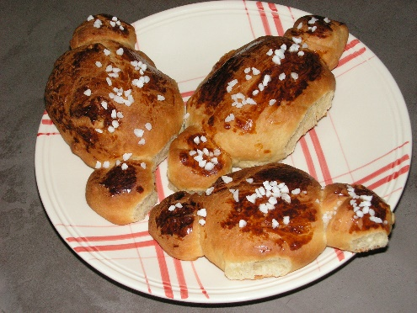 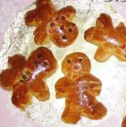

Source: <http://severine06.canalblog.com/archives/2012/12/12/25802153.html>

http://www.cfaitmaison.com/brico/cooking-xmas.html

# Lesson plan 9 The European Language Portfolio: How do I learn languages?

**In this lesson plan the pupils discuss different resources they can use to learn languages.**

# EXPERIENCES

Pupils

* reflect on their language learning strategies
* identify the methods which enable progress in language acquisition
* assess their progress in the area of language acquisition by using the European Language Portfolio (ELP)

# TARGETED COMPETENCES

Pupils

* can learn autonomously (FREPA, skills, S-7.6)
  + can use resources to facilitate their language learning
  + can use linguistic reference tools
  + can use the help of others in order to learn
* can reflect on learning processes in order to make them more effective (FREPA, skills, S-7.7)

# PROCEDURE

BEFORE

|  |  |
| --- | --- |
| plurimobil-icon-discussion-blueplurimobil-icon-question-blue | The teacher encourages pupils to brainstorm what tools and resources can be used for learning languages.  Pupils are invited to think about the ways they are exposed to new languages (e.g. songs, films, magazines, books, computer games, websites, etc.) and the most effective ways they learn a language (i.e. language learning strategies e.g. listening to CDs, reading magazines and simplified children’s books, watching films, websites etc.). |
| plurimobil-icon-individual-work-blueplurimobil-icon-reflexion-blue | Pupils work individually. They fill in the questionnaire from the example section in this lesson plan (European Language Portfolio – Biography). They are invited to give specific examples (e.g. the titles of books and magazines they read, the titles of films, CDs/CD-ROMs, etc.) |
| plurimobil-icon-discussion-blueplurimobil-icon-writing-blue | The teacher elicits answers from pupils in order to discuss what tools for language learning are the most and the least popular. The pupils may prepare a poster e.g. “To learn languages I …” and prepare a list of strategies with appropriate drawings.  Additionally, the teacher may bring and demonstrate different examples of learning resources. |

AFTER

|  |  |
| --- | --- |
| plurimobil-icon-pair-group-work-blueplurimobil-icon-reflexion-blue | The teacher asks the pupils to reflect on their language learning strategies.  Pupils look at the questionnaire from the example section in this lesson plan (European Language Portfolio – Biography) and recall whether they used any resources during the mobility activity. In pairs they compare their development and mark changes, if necessary. They may be encouraged to add new strategies to the poster “To learn languages I …”. |

# FINAL PRODUCT FOR THE PORTFOLIO

List of language learning strategies used by pupils

# TOOLS AND RESOURCES:

*The European Language Portfolio for Children Aged 6-10: My Language Biography* (the Polish version). Warsaw: Centralny Ośrodek Doskonalenia Nauczycieli: p. 6-7, 2006.

The original *European Language Portfolio* is the English version edited by the Council of Europe.

Example 1

European Language Portfolio – Biography

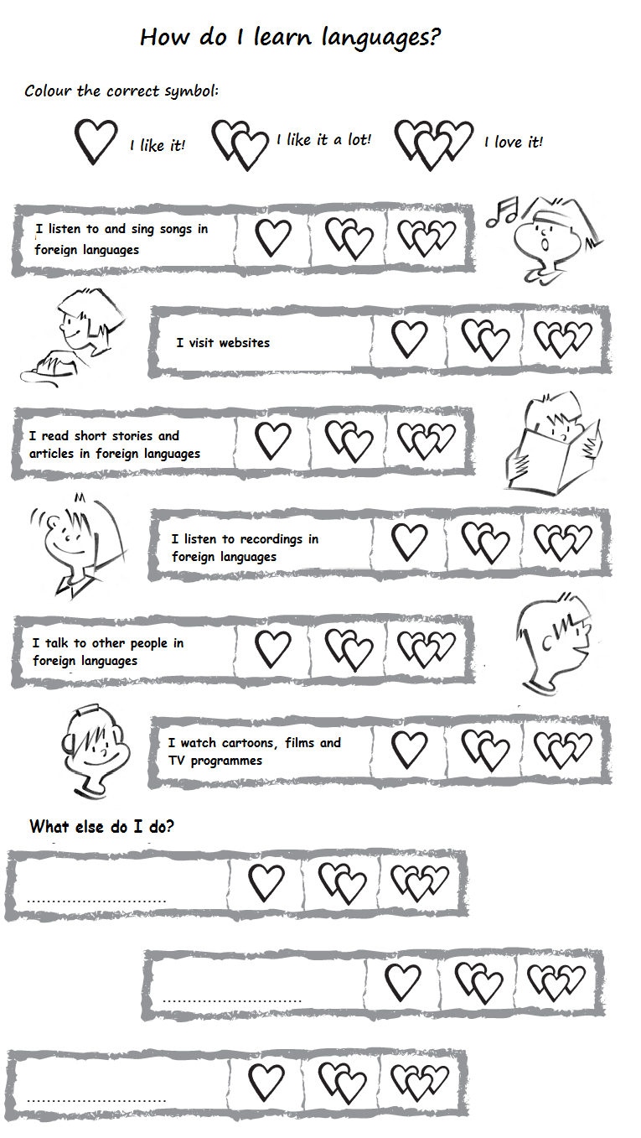

Source: *The European Language Portfolio for Children Aged 6-10: My Language Biography* (the Polish version). Warsaw: Centralny Ośrodek Doskonalenia Nauczycieli: p. 6-7, 2006.

# Lesson plan 10 The words I need …

**In this lesson plan the pupils revise phrases they might need during their mobility activity.**

# EXPERIENCES

Pupils

* are aware that other people may speak different languages
* learn basic ways – linguistically – to get to know other people
* define linguistic needs
* imagine what the mobility activity would be like

# TARGETED COMPETENCES

Pupils

* can identify their learning needs or objectives (FREPA, skills S-7.7)
* can use simple phrases and sentences to communicate with the pupils of their partner class (CEFR spoken production A1, adapted)

# PROCEDURE

BEFORE

|  |  |
| --- | --- |
| plurimobil-icon-discussion-blueplurimobil-icon-writing-blue | Pupils make a list of the language(s) they think may be spoken/ needed at the meeting. |
| plurimobil-icon-pair-group-work-blueplurimobil-icon-speaking-blue | The teacher designs and provides tasks to memorise and practise the useful language elements.  The pupils role play the meeting and greeting of their mobility partners. For this they can use flashcards representing different situations. The pupils can also create some flashcards with the situations they have chosen.  Pupils decide if they need any other language items to make communication better once on their mobility activity:   * to ask for something * to thank * to say what they like/don’t like (if they eat with host families) * to explain a game * … |

DURING

|  |  |
| --- | --- |
| plurimobil-icon-speaking-blueplurimobil-icon-observing-blue | The pupils use what they have learnt.  They can make notes about the new things they have learnt. |

AFTER

|  |  |
| --- | --- |
| plurimobil-icon-individual-work-blueplurimobil-icon-writing-blue | The pupils can add new language that they have learnt or which they now think is necessary and important for their list. |

# FINAL PRODUCT FOR THE PORTFOLIO

List of useful phrases and sentences in another language

Example

Language items that might be interesting

Greetings

* Good morning! Good afternoon!
* Nice to meet you!
* My name’s …? What’s your name?

If they have some free time to do some shopping

* I’d like …
* How much is it?
* Here you are.
* Thank you.

If they eat in a host family

* This is very nice.
* I am sorry, I don’t like …

Sorry, I don’t understand.

Can you repeat that, please?

etc.

# Lesson plan 11 I understand more than I think

**In this lesson plan the pupils look for words in other languages they understand.**

# EXPERIENCES

Pupils

* notice words, phrases, chunks of language that they can understand without help
* are aware that they can understand a lot of language through observation and context

# TARGETED COMPETENCES

Pupils

* can understand familiar names, words and very simple sentences (CEFR reading A1)
* can use what they know of a language in order to understand another language (FREPA, skills S-5)
* can observe or monitor their own learning process (FREPA, skills S-7.7.4)

# PROCEDURE

BEFORE

|  |  |
| --- | --- |
| plurimobil-icon-observing-blueplurimobil-icon-listening-blue | The teacher comes with pictures taken in the home town including words in other languages, possibly in the partners’ languages.  With the pupils they elicit the meaning of the words/phrases. They notice that they can understand things in other languages because of the context, because of the pictogram, etc. |

DURING

|  |  |
| --- | --- |
| plurimobil-icon-observing-blueplurimobil-icon-pair-group-work-blue | The teacher and the pupils have a look around their new surroundings and look carefully at words on shops, signs, posters, advertisements, etc. in order to decode them. |
|  | In mixed groups (home and host), pupils write down some of the language they see in their new surroundings. They try to find out what it means and the host pupils help them pronounce the new words correctly. |

AFTER

|  |  |
| --- | --- |
| plurimobil-icon-virtual-exchange-blueplurimobil-icon-pair-group-work-blue | Pupils can create a wordle with the words in foreign languages they understand (see the example). |

# FINAL PRODUCT FOR THE PORTFOLIO

* list of new words
* wordle

# TOOLS AND RESOURCES

Websites where you can create a wordle:

<http://www.youtube.com/watch?v=bpVXq0koi1U> – how to create a wordle

Example 1

Some pictures taken in a French-speaking environment and showing the use of other languages

Pupils are invited to look at the pictures, to guess the languages used and the meaning.

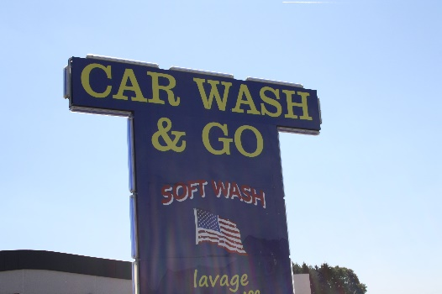 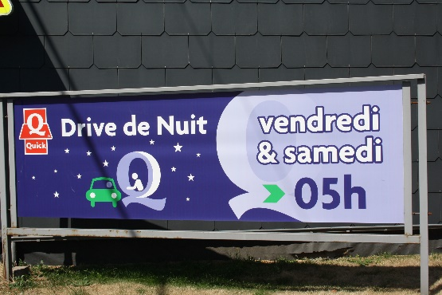

 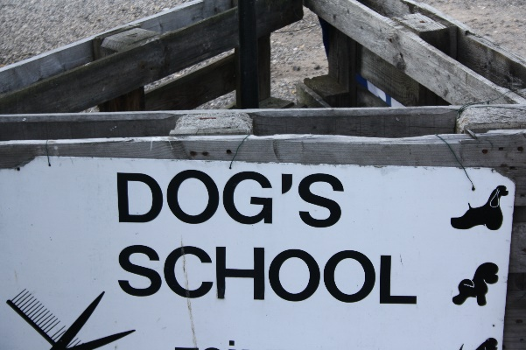

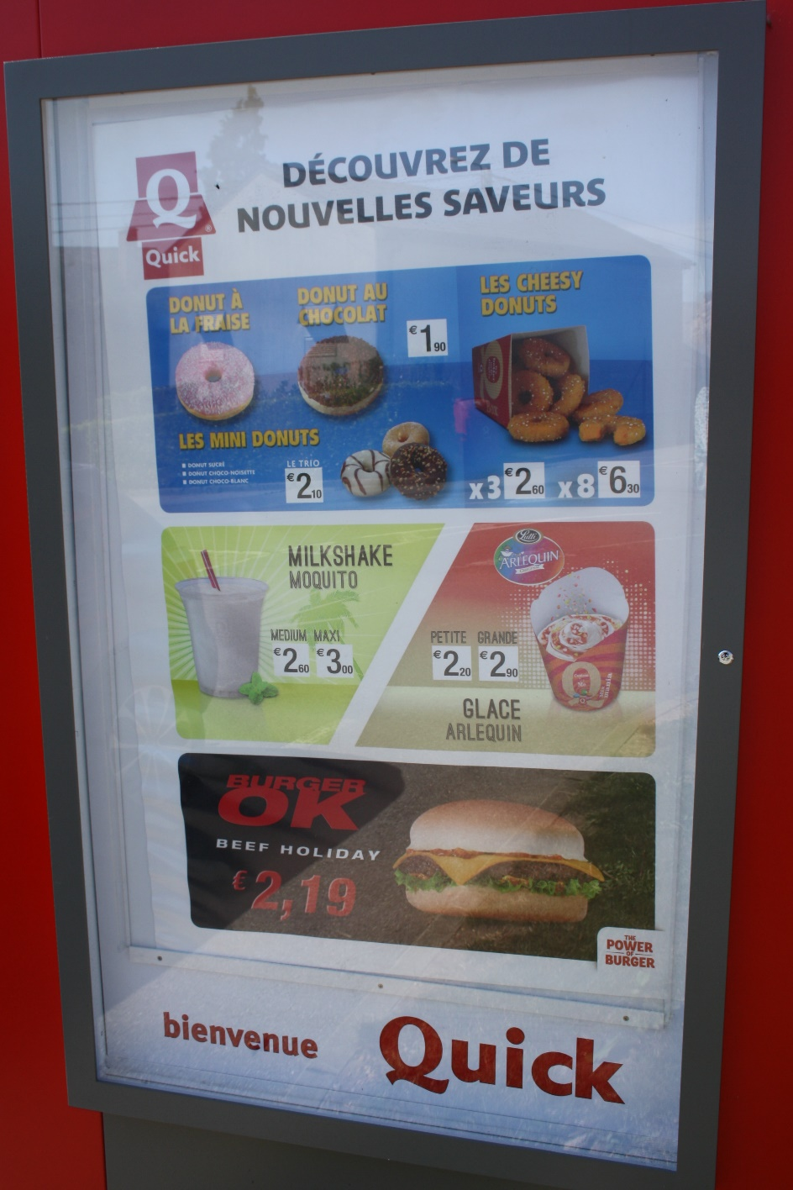

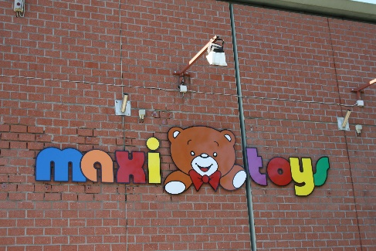 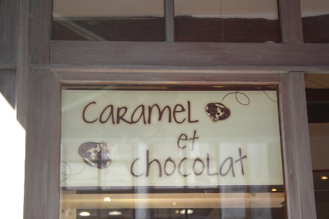

Example 2

**Example of a wordle**

See example of wordle with international, transparent words.



# Lesson plan 12 I will show you my town

**In this lesson plan the pupils prepare games and activities for their guests.**

# EXPERIENCES

Pupils

* plan what they would do if they were to host a mobility activity

# TARGETED COMPETENCES

Learners

* can better understand their own cultural identity (ICCinTE, p. 13)
* can identify cultural specificities (FREPA, skills, S-2)
* can perceive differences and similarities in different aspects of social life (FREPA, skills, S-3.10.2)
* can compare features of culture (perceive the cultural proximity/distance) (FREPA, skills, S-3.10)

# PROCEDURE

BEFORE

|  |  |
| --- | --- |
| plurimobil-icon-question-blueplurimobil-icon-pair-group-work-blue | In pairs, pupils discuss what they would like to show their mobility partner in their town.  Teacher and pupils list the different suggestions. The teacher might elicit some more elements that have not come up and that might be interesting.  **Alternative version:** the teacher and the pupils go together to the place they will visit and note down what they think are its interesting features. |
| plurimobil-icon-virtual-exchange-blueplurimobil-icon-discussion-blue | Together they decide on a possible itinerary, not too long, not too short, including some of the interesting elements mentioned earlier. They look for information on the different sites visited.  They reflect on how they could make the visit more attractive and enjoyable. They list different ways of doing it:   * treasure hunt * observation tasks * quiz * drawings * asking for/finding out some information * …   They prepare a mini-book with all the tasks to perform, which will accompany the partners during the visit. |

DURING

|  |  |
| --- | --- |
| plurimobil-icon-pair-group-work-blue | The pupils and the host pupils play the treasure hunt, the game. |

AFTER

|  |  |
| --- | --- |
| plurimobil-icon-discussion-blueplurimobil-icon-reflexion-blue | The pupils reflect on what they have learnt about their home town. |

# FINAL PRODUCT FOR THE PORTFOLIO

* game
* treasure hunt
* quiz

**Example 1**

In a square – each pupil draws the shape of one building of his/her choice. The papers are mixed and distributed. Nobody should receive his own drawing. The pupils have to find the building drawn.

One pupil describes the drawing he has received, while the others guess which one it is.

One pupil has got a drawing. The others ask yes/no questions. The pupil can also say that s/he doesn’t know.

Pupils are invited to count, in a limited amount of time, the number of trees, of chimneys, of balconies, etc.

Pupils are put in groups. A colour is chosen. One group must spot and name an object with this colour. Then it’s the turn of group 2, etc. until there is one group left, they are the winners.